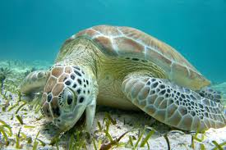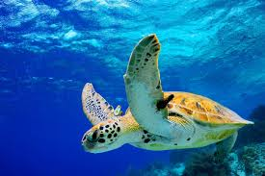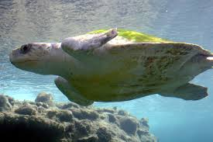

JELLYFISH

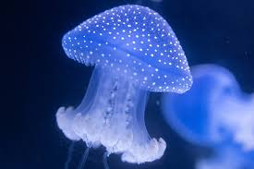

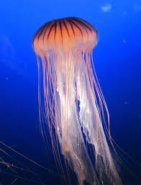

PACIFIC OCEAN GARBAGE PATCH

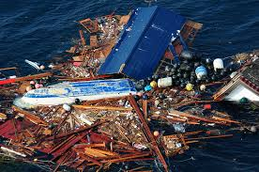

What is the Pacific Ocean Garbage Patch?

The Great Pacific Garbage Patch is a huge area in the Pacific Ocean where plastic trash and other waste collect together. It forms because ocean currents spin in a circle (called a gyre) and trap floating garbage.
It is located roughly between California and Hawaii.
Surprising facts students usually remember
The garbage patch is not a solid island of trash — it’s more like a “plastic soup” floating in the water.
Scientists estimate it covers an area about twice the size of Texas.
Most of the trash is tiny pieces of plastic called microplastics.
Plastic can take hundreds of years to break down.
About 80% of ocean plastic comes from land, carried by rivers and wind.
The rest comes from fishing nets, boats, and ocean activity.
Why is it a problem?
Plastic pollution can harm ocean life:
Fish and birds may eat plastic by mistake.
Animals can get caught in fishing nets or plastic rings.
Tiny plastic pieces can enter the food chain.
Scientists worry that plastic pollution affects both animals and humans.
What are people doing about it?
Some groups are working to clean the ocean using large floating collection systems and by reducing plastic use on land.
One important idea students understand easily:
The best way to stop ocean garbage is to prevent plastic from reaching the ocean in the first place.

